TEAM 415 P.R.I.D.E. - American History
Warren Mott High School 2016-2017
Parents and Students,
This year long class covers American History from the end of the Civil War & Reconstruction Era to the Vietnam War. Please read and discuss the following policies, kindly sign on the space provided and return tomorrow.
At Warren Mott High School we make showing Mott P.R.I.D.E. a daily goal. Students have discussed how important the following qualities are in high school as we strive to achieve rigorous academic goals and high standards as a team!

RESPECTFUL:
Raise your hand to speak, and listen when others are speaking.
Please stop everything IMMEDIATELY when you hear the bell.
At the end of class ALWAYS wait to be dismissed.
Respect your textbook and our classroom.
In class it is disrespectful to leave your phone on ring, text,
put your head down on your desk, do other homework, listen to music
WITHOUT permission, use offensive language, and pack up early.
Participation points will be lost for any of these actions.

Materials:

-3-ring binder (1.5-2 inches)
-5 dividers/page protectors
-Lined Paper
-Pencils or blue/black pens
DUE Friday JAN 27
*optional: We use a lot of
tissues, hand sanitizer,
and anti-bacterial wipes
throughout the year. If you
could donate any of these
items it would be greatly
appreciated!
PREPARED:
You will come to class with your ID around your neck and have your book, binder, paper (or notebook), assignments and pencils.
You will not come to class in violation of the school dress code, with food (yes this means candy!), drink, hats, purses and/or backpacks.
*If any of these items is brought to class or you are dressed inappropriately,
I will ask you to leave to take care of the situation and you will take a tardy.

INVOLVED:
PARTICIPATE! Be involved in games, note-taking, and discussions. Pay attention to what is going on, follow directions, ask questions, share opinions, and do not be afraid to make mistakes.
Do your own work. No cheating or letting others cheat off of you!
Every two weeks you will receive a participation grade based on your P.R.I.D.E. in class and you will earn bonus points for completing team activities successfully!

WHILE YOU WERE OUT…
Review the schedule on the website to see
what you have missed.
You are responsible to make up any work missed due to an excused absence in the same number of days that you were excused.
Work due must be turned in to the your hour’s tray.
A test taken the day you were absent must be made up the day you return (it may be different than the original).
All papers distributed during your absence will be in the “While You Were Out” file. Find your hour, remove
any missed or graded handouts with your name on
them, ask a friend to explain, and then see me
outside of class if you have additional questions.

DETERMINED:
Get to class on time every time! Make sure that you have all of your materials before coming to class.
I follow the school tardy rule:
3 tardy=detention, 5=referral, 7=suspension
Focus on learning ALL hour!
Meet deadlines and use the class website. Each week, class lesson plans are on the website (http://syswerda.weebly.com/index.html).
Homework is expected to be done at home and complete before the starting bell the next day.
Work turned in to the tray after class starts will receive HALF credit.
Work EXTRA hard when you are absent.

ENTHUSIASTIC:
LEARNING is our main focus, YOUR SUCCESS IS IMPORTANT!!
My job is to teach you and help you learn. Your job is to challenge yourself and to try your best!
Be positive & support one another, we are a team & there is no room for negative attitudes in this class.
Cheer each other on and have fun during games. Competition is fun but a sore loser is not!
NO WHINING or COMPLAINING is allowed!
Smile more and encourage each other, we all have to be here so let’s make it FUN!

PASSES
- The bathroom is to be used during 5 minute breaks
- Only 2 passes each semester and only for EXTREME emergencies
- You may NOT leave the first or the last 10 minutes of class
- I record the passes that you use
- You need to be in class to learn!

Thank-you in advance for
your cooperation!
I’m looking forward to a great semester working
with you! Work hard, do your absolute best
and know you can be successful! I’m here to
help you succeed. Let me know if you need
extra help and we will set up a time to work
CONTACT ME:
Ms. Abbey Syswerda Room 415
asyswerda@wcskids.net
(586) 574-3250 ext. 13415
http://syswerda.weebly.com

together either before school, after school, or
during lunch. Please don’t hesitate to ask for
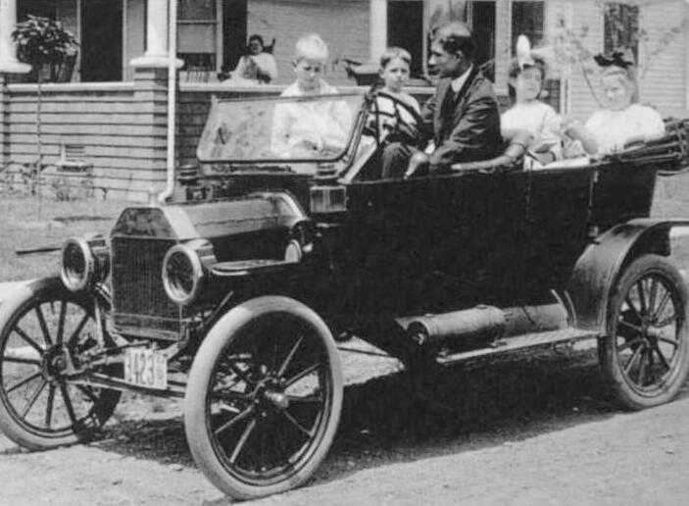
extra help!

---------Detach here and return-------------Detach here and return--------------------Detach here and return-----------

Student name :__________________________________________hour_______

Student’s signature:_______________________________________Parent’s signature: ____________________________________________________

Parent’s phone number:________________________________________________________________________________________________________

Parent’s email:__________________________________________________________________________________________________________________
Please let me know if there is any other important information I should know about your child :_____________________________________________________
____________________________________________________________________________________________________________________________________________________________________________________________________________________________________________________________________________________________________________________________________________________________________________________________________________________________________________________________________________

